# Design Overview for TetrisSharp

Name: Duong Quang Thanh

Student ID: 104167828

# Summary of Program

TetrisSharp is a captivating game inspired by the classic puzzle sensation Tetris, implemented using the SplashKit SDK for graphical user interface and game development. At its core, TetrisSharp features a grid-based game board where the block—comprised of four square blocks—cascade downwards.

Players can easily control these shapes, using keyboard controls for movement and rotation, to form complete horizontal lines. Upon completing a line, it disappears, earning the player points. The game mechanics encompass essential elements such as line clearing, shape manipulation, collision detection, and scoring calculations. With the ability to start and restart the game, players can continuously refine their Tetris prowess and strive for higher scores. TetrisSharp faithfully recreates the beloved Tetris experience, offering both enjoyment and challenge in equal measure.

Here is the sketch of the game:

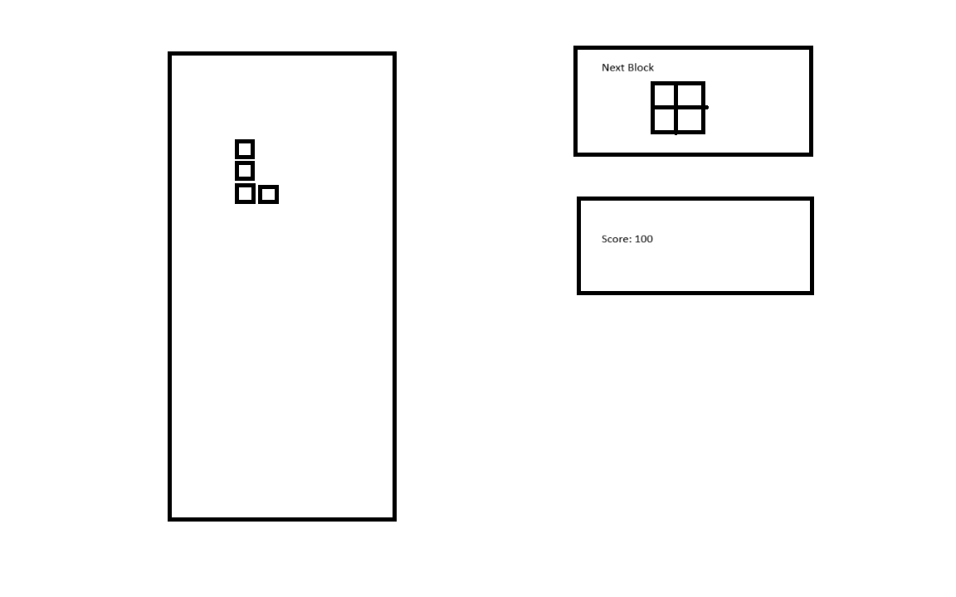

# Required Roles

Describe each of the classes, interfaces, and any enumerations you will create. Use a different table to describe each role you will have, using the following table templates.

Table 1: <<role name>> details – duplicate

|  |  |  |
| --- | --- | --- |
| Responsibility | Type Details | Notes |
| GameGridClass | This class contains column, rows number, color of cell and the methods to check whether that rows is full of blocks or not, it returns the gameboard attributes. |  |
| PositionClass | This class return row and column position. |  |
| BlockClass | This class contains position of the block, tile of block. |  |
| GameStateClass | This class contain the game logic and game implement such as score, clear the completed line, rotate block, move block. |  |

# Class Diagram

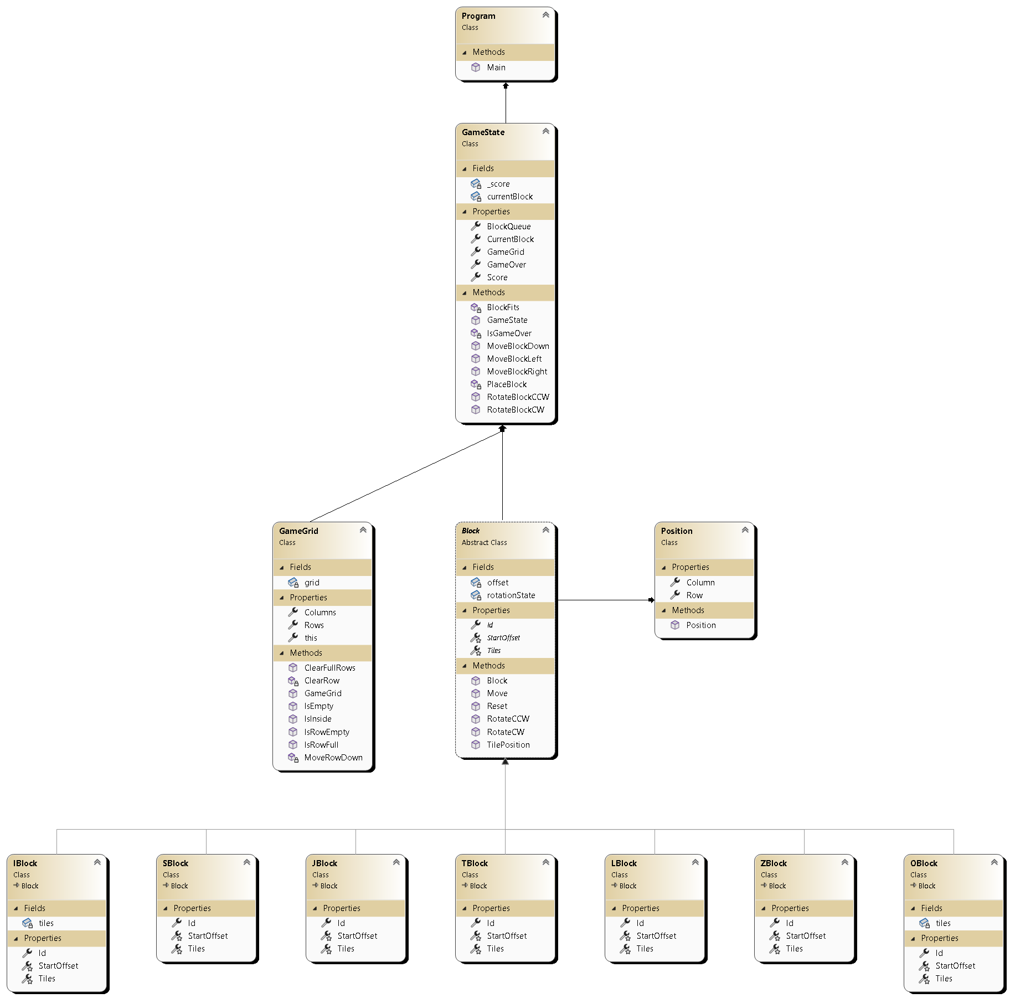

# Sequence Diagram

